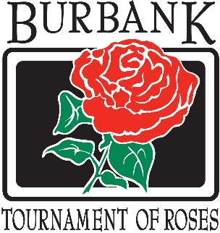

**Burbank Tournament**

**of Roses Association**

**ANNUAL BANQUET**

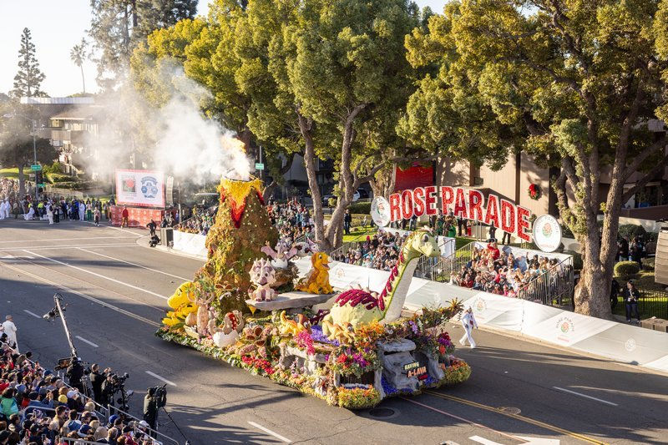

“**Having A-Lava Fun!**”

Winner of the **Animation Award**

Designed by **Erik C. Andersen**

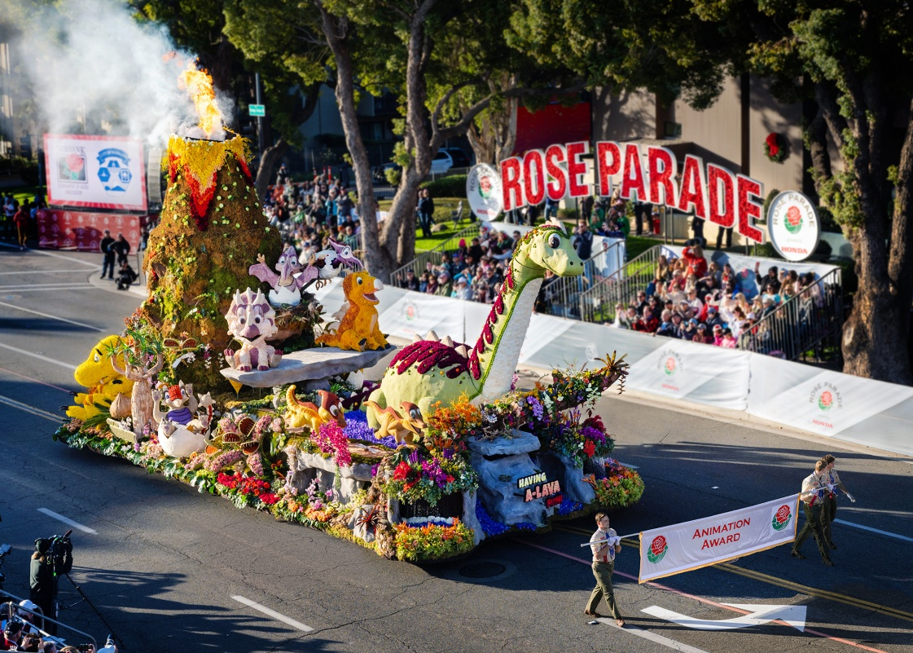

Saturday, March 22, 2025

6:00 p.m.

Trevor Hall

**First United Methodist Church**

700 N Glenoaks Blvd.

Burbank, CA 91502-1031

Thank you to everyone who contributed time, effort and love to the 2025 float. Every volunteer is an integral part of this team effort! Together we make it happen!!

**Program**

**Reception & Silent Auction**

**Welcome**

(Bert Champagne)

**Introduction of Special Guests**

(Linda Cozakos - President)

**Dinner and Slide Show**

**De-Installation of 2024-2025 Board of Directors**

**Installation of 2025-2026 Board of Directors**

(Mayor Nikki Perez - City of Burbank)

**2025 Tournament Award Presentation**

(Ed Morales - Past President of Pasadena

Tournament of Roses Association)

**Special Appreciations**

(Linda Cozakos - President)

**Silent Auction Winners**

(Bert Champagne)

Thank you for your service

**Board of Directors 2024-2025**

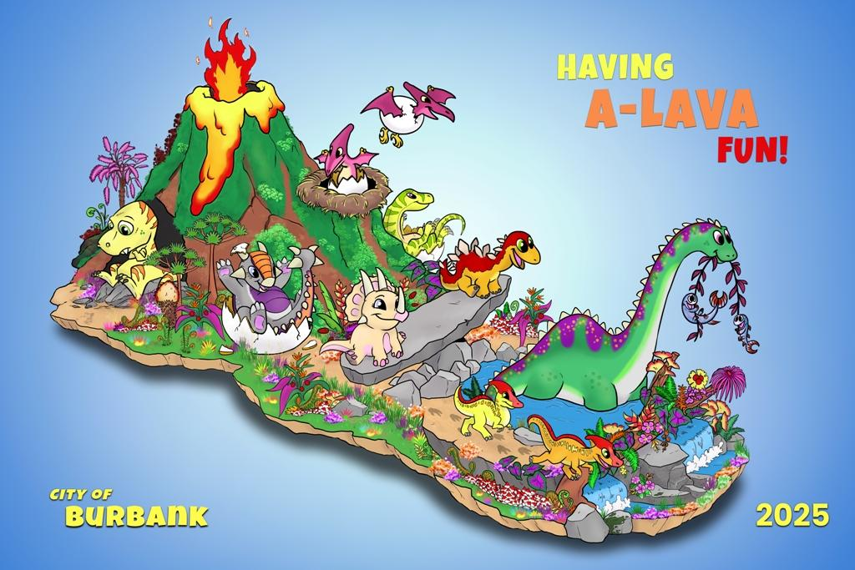

**Float Designer 2025 – Erik C. Anderson**

**Linda Cozakos,** President

**Bob Hutt,** Vice President of Administration

**Steven Edward,** Vice President of Float

**Robin Hanna,** Treasurer

**Jon Reeves,** Secretary

**Kim Brunner**

**Kim Cecchettini​**

**Terri Coomes**

**Teresa Green**

**Liza Diaz**

**John Hames**

**Albert Rodriguez2024/2025**

**Committee Chairs**

Audit 2024 (**Lisa DeLuca/Jodi Gross/Leslie Monzon**)

Banquet 2024 (**Kim Brunner**)

Construction (**Jon Reeves**)

Craft Faire and Open House (**Kim & Jeff Cecchettini**)

Decorations (**Terri Coomes**)

Design (**Rosanne and Bob Ford**)

Design Contest (**Audrey Prest**)

Food Services (**Rosanne and Bob Ford**)

Fundraising (**Barbara Williams**)

Manpower (**Teresa Green)**

Music (**Erik C. Andersen/Ben Knorr-Composer**)

Nominating **(Bob Ford)**

Publicity (**Bob Hutt**)

Site and Safety (**Albert Rodriguez**)

Liaison with BWP (**Janet Diel**)

Historian (**Erik C. Andersen**)

You provided leadership and guidance for our organization throughout the year. Thank you also to all the volunteers who worked and contributed to the 2025 float.

Welcome the new

**Board of Directors 2025-2026**

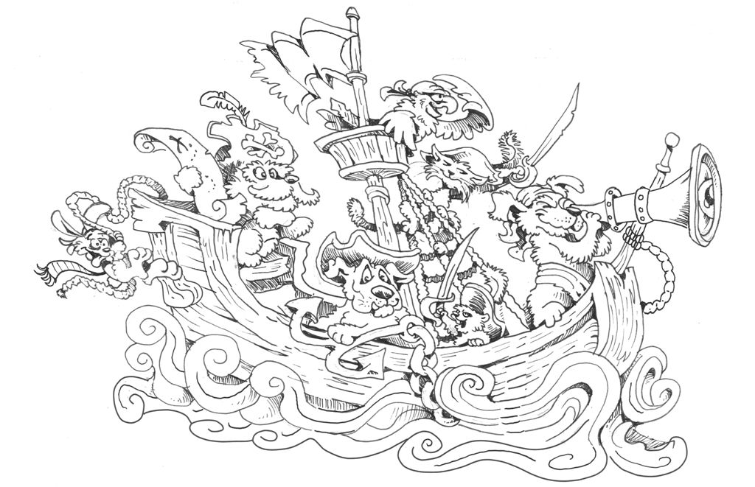

**Float Designer 2026 - Dave Lowe**

**Linda Cozakos,** President

**Bob Hutt,** Vice President of Administration

**Steven Edward,** Vice President of Float

**Robin Hanna,** Treasurer

**Jon Reeves,** Secretary

**Rick Bauer**

**Kim Brunner**

**Jeff Cecchettini**

**Kim Cecchettini**

**Terri Coomes**

**Teresa Green**

**Audrey Prest**

**2025/2026**

**Committee Chairs**

Audit 2025 (**tbd**)

Banquet 2025 (**Kim Brunner**)

Construction (**Jon Reeves**)

Craft Faire and Open House (**Kim & Jeff Cecchettini**)

Decorations (**Terri Coomes**)

Design (**Bert Champagne and Steven Edward**)

Design Contest (**Audrey Prest**)

Food Services (**Rosanne and Bob Ford**)

Fundraising (**Barbara Williams**)

Manpower (**Teresa Green**)

Nominating **(Audrey Prest)**

Publicity (**Bob Hutt**)

Site and Safety (**Albert Rodriguez**)

Liaison with BWP (**Janet Diel**)

Historian (**Erik C. Andersen**)

We look forward to having you lead us through this coming year and preparing us for the 2026 entry, temporary name is “Pet Pirates”. It will be a fun year working together!!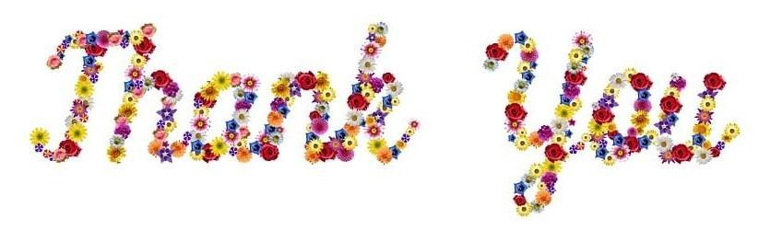

**Master of Ceremonies**

Bert Champagne

**Banquet Committee**

Kim Brunner – Chair

Jeff Cecchettini ☼ Kim Cecchettini ☼ Linda Cozakos

Lisa DeLuca ☼ Mike Everhart ☼ Steven Edward ☼ Robin Hanna Rose Kennedy ☼ Ginny Meyers ☼ Audrey Prest ☼ Ligia Rodriguez Barbara Williams

**Food Servers**

National Charity League

**A huge Thank You to all our banquet donors for all of your support**

**Deco Week Food Vendors**

BARRAGAN’S ☼ CHICK-FIL-A ☼ CHILI JOHN'S OF CA ☼ CORAL CAFÉ ☼ HANDY MARKET ☼ HILL STREET CAFÉ ☼ LANCERS FAMILY RESTAURANT ☼ MARTINO’S BAKERY ☼ MUCHO MAS ☼ POPEYES LOUISIANA KITCHEN ☼ RAISING CANE'S ☼ SANTORO’S SUBMARINE SANDWICH ☼ TACO BELL ☼ WESTERN BAGEL ☼ WIENERSCHNITZEL ☼ ARNIE PADILLA & TINA SCHAEFER

**In loving memory of those who are forever in our hearts**